## PathPathfinder Society Character Creator – Original Project Submission

This program helps a user create a new character for the Pathfinder Society (*PFS*) role-playing game system. It will begin with selecting a name, class, race, alignment, then calculate a Point Buy system. This will also feature a randomized die roll for a D100, D20, D12, D10, D8, D6, D4, and D2 and a result display.

I thought of creating this application because, due to the pandemic, my social time playing games with friends has shifted online and virtual. This project is to help me understand the mechanics of a game I enjoy, and to find ways where a program can automate calculations and help guide creating a character.

Goals for the application are to successfully implement a button based point-buy system for stats including a choose for me button based on user selected class, buttons for randomized die rolls, selection of a character class, race, and alignment, and display of a character image. Character Class and Race will open new windows for a button based menu selection. A button to start over and reset variables to initial values should be included, as well as a Save button to allow output to a file.

My target audience would be Pathfinder Society players wanting to tinker with new character builds, explore stats, and to have a randomized die rolling at the click of a button.

GUI Outline:  
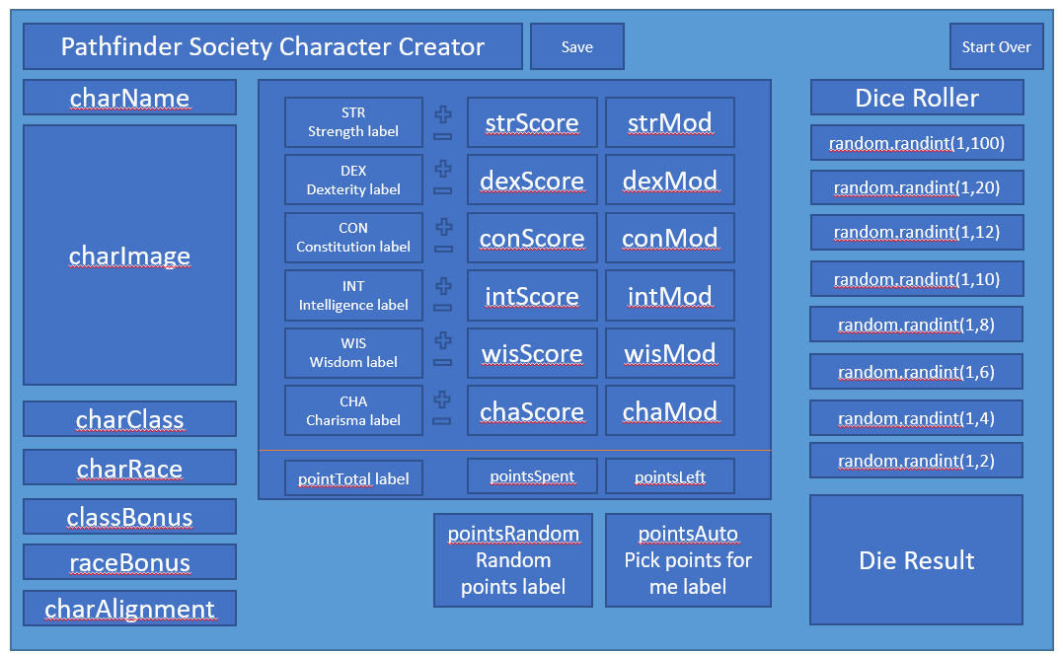

## Project Documentation

Enter Character Name  
 charName = str(input(“Please enter a name for your character: “))

Select Character Class  
 Barbarian  
 Bard  
 Cleric  
 Druid  
 Fighter  
 Monk  
 Paladin  
 Ranger (Archer)  
 Ranger (Melee)  
 Rogue  
 Sorcerer  
 Wizard

Character Image  
 If Class = Barbarian = charImage = barbarian.jpg  
 If Class = Bard = charImage = bard.jpg  
 If Class = Cleric = charImage = cleric.jpg  
 If Class = Druid = charImage = druid.jpg  
 If Class = Fighter = charImage = fighter.jpg  
 If Class = Monk = charImage = monk.jpg  
 If Class = Paladin = charImage = paladin.jpg  
 If Class = Ranger (Archer) = charImage = rangerarcher.jpg  
 If Class = Ranger (Melee) = charImage = rangermelee.jpg  
 If Class = Rogue = charImage = rogue.jpg  
 If Class = Sorcerer = charImage = sorcerer.jpg  
 If Class = Wizard = charImage = wizard.jpg

Select Character Race  
 Dwarf Bonus to Con, Wis Minus to Cha  
 Elf Bonus to Dex, Int Minus to Con  
 Gnome Bonus to Con, Cha Minus to Str  
 Half Elf +2 Bonus to one  
 Half Orc Bonus to Dex, Cha Minus to Str  
 Halfling +2 Bonus to one  
 Human +2 Bonus to one

Class Bonus – remove this, class bonus out of scope for point buy

Race Bonus  
 If charRace = Dwarf +2 conScore, +2 wisScore, -2 chaScore  
 If charRace = Elf +2 dexScore, +2 intScore, -2 chaScore  
 If charRace = Gnome +2 conScore, +2 chaScore, -2 strScore  
 If charRace = Halfling +2 dexScore, +2 chaScore, -2 strScore  
 If charRace = Half Elf, Half Orc, Human +2 score of choice

Alignment  
 9 grid display of alignment chart

|  |  |  |
| --- | --- | --- |
| LG | NG | CG |
| LN | N | CG |
| LE | NE | CE |

#Error if any Evil Alignment is chosen

Point Buy  
 20 point pool  
 Base state is 10  
 MOD goes up every 2 points past 10  
 MOD goes down every 2 points below 10, starting at 9  
 If score if less than 7, error  
 If Score is 7-8, points cost -2 per point  
 If Score is 9-10, points cost -1 per point  
 If Score is 10-12, points cost 1 per point  
 If Score is 13-15, points cost 2 per point  
 If Score is 16-17, points cost 3 per point  
 If Score is 18, points cost 4 per point

Random point buy – remove this, random point buy not very useful for players  
Replace with Reset points  
 Set points spent to 0  
 Set points left to 20  
 Set all scores to 10

Auto Point Buy  
 If Class = Barbarian – strScore = 17, dexScore = 14, conScore = 14, intScore = 8, wisScore = 13, chaScore = 7  
 - strMOD = 3, dexMOD = 2, conMOD = 2, intMOD = -1, wisMOD = 1, chaMOD = -2  
  
 If Class = Bard – strScore = 12, dexScore = 14, conScore = 14, intScore = 11, wisScore = 11, chaScore = 15  
 - strMOD = 1, dexMOD = 2, conMOD = 2, intMOD = 0, wisMOD = 0, chaMOD = 2  
  
 If Class = Cleric – strScore = 13, dexScore = 10, conScore = 12, intScore = 8, wisScore = 18, chaScore = 10  
 - strMOD = 2, dexMOD = 0, conMOD = 1, intMOD = -1, wisMOD = 4, chaMOD = 0  
  
 If Class = Druid – strScore = 14, dexScore = 14, conScore = 14, intScore = 9, wisScore = 16, chaScore = 7  
 - strMOD = 2, dexMOD = 2, conMOD = 2, intMOD = -1, wisMOD = 3, chaMOD = -2  
  
 If Class = Fighter – strScore = 15, dexScore = 17, conScore = 14, intScore = 7, wisScore = 13, chaScore = 8  
 - strMOD = 2, dexMOD = 3, conMOD = 2, intMOD = -2, wisMOD = 2, chaMOD = -1  
  
 If Class = Monk – strScore = 17, dexScore = 13, conScore = 14, intScore = 8, wisScore = 16, chaScore = 7  
 - strMOD = 3, dexMOD = 1, conMOD = 2, intMOD = -1, wisMOD = 3, chaMOD = -2  
  
 If Class = Paladin – strScore = 16, dexScore = 12, conScore = 14, intScore = 10, wisScore = 8, chaScore = 14  
 - strMOD = 3, dexMOD = 1, conMOD = 2, intMOD = 0, wisMOD = -1, chaMOD = 2  
  
 If Class = RangerArcher – strScore = 12, dexScore = 18, conScore = 12, intScore = 10, wisScore = 13, chaScore = 7  
 - strMOD = 1, dexMOD = 4, conMOD = 1, intMOD = 0, wisMOD = 2, chaMOD = -2  
  
 If Class = RangerMelee – strScore = 16, dexScore = 14, conScore = 14, intScore = 11, wisScore = 13, chaScore = 7  
 - strMOD = 3, dexMOD = 2, conMOD = 2, intMOD = 0, wisMOD = 2, chaMOD = -2  
  
 If Class = Rogue – strScore = 8, dexScore = 17, conScore = 14, intScore = 12, wisScore = 11, chaScore = 12  
 - strMOD = -1, dexMOD = 3, conMOD = 2, intMOD = 1, wisMOD = 0, chaMOD = 1

If Class = Sorcerer – strScore = 7, dexScore = 12, conScore = 13, intScore = 10, wisScore = 12, chaScore = 18  
 - strMOD = -2, dexMOD = 1, conMOD = 1, intMOD = 0, wisMOD = 1, chaMOD = 4  
  
 If Class = Wizard – strScore = 7, dexScore = 14, conScore = 14, intScore = 18, wisScore = 11, chaScore = 7  
 - strMOD = -2, dexMOD = 2, conMOD = 2, intMOD = 4, wisMOD = 1, chaMOD = -2

Set points spent to 20  
 Set points left to 0  
#Scores from suggested values via <https://rpgbot.net/pathfinder/characters/classes/>

Dice Roller  
 Roll D20 – random(1,20) #Most commonly rolled  
 Roll D100 – random(1,100)  
 Roll D12 – random(1,12)  
 Roll D10 – random(1,10)  
 Roll D8 – random(1,8)  
 Roll D6 – random(1,6)  
 Roll D4 – random(1,4)  
 Roll D2 – random(1,2)  
 print Die Result in box

Start Over  
 Reset all variables to default/blank

Save   
 Output text file – no die roller

Completed:

Pseudocode and known settings.

Desired Layout of labels, buttons, inputs.

In Progress:

Writing code for GUI application - coding labels, buttons, and inputs.

On-going project documentation

Problem areas:

Layout of rows for conforming to Window size – Rows are way too far apart at this point.

Research for prompt box to include radio buttons, not just a string input